Linus Lee Wahman
February 15, 1895 – November 21, 1950

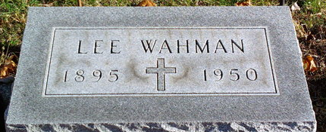
Photo by Thomas Liby

Lee H Wahman
in the Indiana, U.S., Death Certificates, 1899-2017
Name Lee H Wahman
Gender Male
Race White
Marital Status Married
Age 55
Veteran World War I
Birth Date 15 Feb 1895
Birth Place Oldenburg, Indiana
Death Date 21 Nov 1950
Death Place Bluffton, Wells, Indiana, USA
Death Registration Date 1950
Father Bernard Wahman
Mother Rose Hoelker
Informant Mrs. Lee Wahman
Burial November 24, 1950; Elm Grove Cemetery; Bluffton, Indiana

