Donnajeanne C. Wahman
November 25, 1921 – April 20, 1999

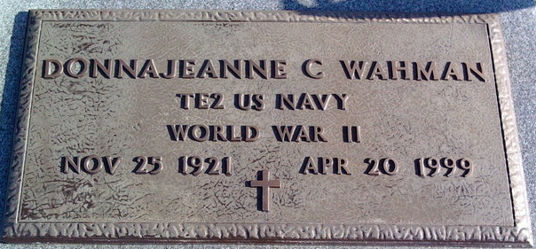
Photo by Thomas Liby

Donnajeanne C. Wahman, 77, of Bluffton, a retired Indiana Bell employee, died at 11:30 a.m. Tuesday at Christian Care Retirement Center.
Miss Wahman was employed 37 years with Indiana Bell prior to her retirement. She was a 1938 graduate of Bluffton High School, a past president of Sigma Phi Gamma Sorority, and a member of St. Joseph Catholic Church, Telephone Pioneers Club and American Legion Post 111. She served with the U.S. Navy during World War II.
Miss Wahman was born Nov. 25, 1921 at Bluffton to Linus "Lee" and Lucille Knoke Wahman.
Surviving is a brother, Bernard H. Wahman of Ocala, Fla.; a sister, Mrs. William (Rose Ann) Lautzenheiser of Bluffton and several nieces and nephews. A brother, Joe, is deceased.
Services will be at 10 a.m. Friday at St. Joseph Catholic Church with Father Larry Kramer officiating. Burial will be in Elm Grove Cemetery. Visitation hours at Goodwin Memorial Chapel will be Thursday from 2 to 9 p.m., with a prayer vigil at 7:30 p.m. Thursday.
Memorials to the church.

Bluffton News-Banner, Wells County, Indiana
April 21, 1999
**

Donnajeanne C. Wahman
in the Indiana, U.S., Death Certificates, 1899-2017
Name Donnajeanne C. Wahman
Gender Female
Race White
Marital Status Single
Age 77
Birth Date 25 Nov 1921
Birth Place Bluffton, Indiana
Death Date 20 Apr 1999
Death Place Bluffton, Wells, Indiana, USA
Death Registration Date 1999
Father Linus Wahman
Mother Lucille Knoke
Informant Rose Lautzenheiser; sister; Bluffton, Indiana
Burial April 23, 1999; Elm Grove Cemetery; Bluffton, Indiana

