Rick A. Waggoner, Sr.
March 7, 1961 -

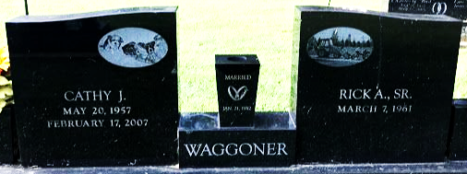
Photo by SMMR

