Cathy J. (Wolfe) Waggoner
May 20, 1957 – February 17, 2007

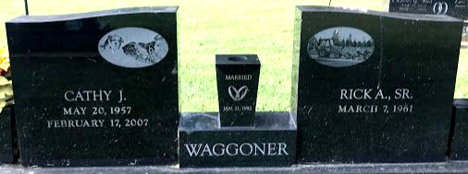
Photo by SMMR

Cathy J. Waggoner, 49, of Bluffton died from cancer at 4:50 a.m. Saturday, Feb. 17, 2007, at Bluffton Regional Medical Center. She had been ill since March.
Over the years, Mrs. Waggoner had been employed by Bluffton Rubber Company, Manley Meats, Bluffton Cemeteries Inc. and the Bluffton Wal-Mart store. She attended Pleasant Mills United Methodist Church and was a 1975 graduate of Adams Central High School.
Born on June 20, 1957, in Adams County, she was a daughter of Clyde and Shirley (Williamson) Wolfe, who survive and reside in Decatur. Her marriage on Jan. 21, 1992, in Bluffton was to Rick A. Waggoner Sr., who survives.
Other survivors include daughters Rachel J. Gerber of Denver, Colo., and Rebecca J. Gerber of Bluffton; a son Jason D. Gerber of Bluffton; a stepson, Rickie A. Waggoner Jr. of Ocala, Fla.; a sister, Nancy (Randy) Hirschy of Monroe; a brother, Dennis Wolfe of Monroe; and four grandchildren.
Calling is from 1 to 8 p.m. Tuesday at Thoma/Rich, Hewitt & Chaney Funeral Home. Services are at 10:30 a.m. Wednesday at the funeral home with Pastor Michele D. Isch officiating. Burial will be in the Garden of Chimes at Elm Grove Cemetery.
Preferred memorials are to Pleasant Mills United Methodist Church, the American Cancer Society or the family.

Thoma/Rich Funeral Home, Wells County, Indiana
February 18, 2007

