Susannah Jane (Crook) Vore
January 14, 1838 – June 15, 1921

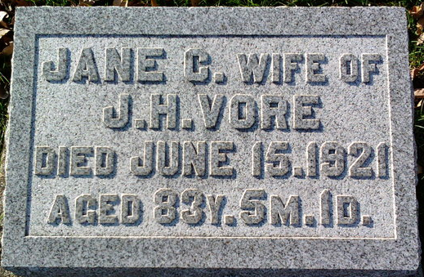
Photo by Thomas Liby

Jane Crook Vore
in the Indiana, U.S., Death Certificates, 1899-2017
Name Jane Crook Vore
[Jane Crook]
Gender Female
Race White
Marital Status Married
Age 83
Birth Date 14 Jan 1838
Birth Place Pennsylvania
Death Date 15 Jun 1921
Death Place Bluffton, Wells, Indiana, USA
Death Registration Date 1921
Father Leonard Crook
Mother June Peck
Spouse John Vore
Informant John Vore; Bluffton, Indiana
Burial June 17, 1921; Elm Grove Cemetery

