Rachel Rosetta (Jackson) Vore
April 4, 1868 – November 17, 1944

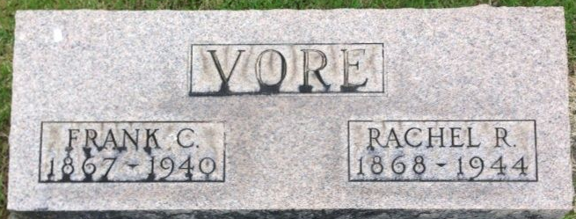
Photo by Thomas Liby

Rosette Jackson Vane
in the Indiana, U.S., Death Certificates, 1899-2017
Name Rosetta Jackson Vore
[Rosetta Jackson]
Gender Female
Race White
Marital Status Widowed
Age 76
Birth Date 4 Apr 1868
Birth Place Wells Co Indiana
Death Date 17 Nov 1944
Death Place Wells Co Hospital, Wells, Indiana, USA
Death Registration Date 1944
Father Samuel Jackson
Mother Sarah Foust
Spouse Frank L Vore; deceased
Informant Mrs. Lloyd Irwin; Fort Wayne, Indiana
Burial November 19, 1944; Elm Grove Cemetery; Bluffton, Indiana

