Nile H. Vore
September 5, 1898 – August 27, 1980

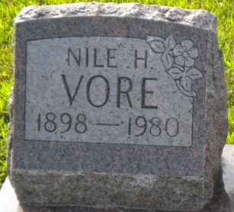
Photo by PLGS

Nile H. Vore
in the Indiana, U.S., Death Certificates, 1899-2017
Name Nile H. Vore
Gender Male
Race White
Marital Status Married
Age 81
Birth Date 5 Sep 1898
Birth Place Indiana
Death Date 27 Aug 1980
Death Place Fort Wayne, Allen, Indiana, USA
Death Registration Date 1980
Father Reynolds Vore
Mother Emma Fry
Spouse Lulu Witzenman
Informant Philip Souder; Adm.; Warren, Indiana
Burial August 29, 1980; Elm Grove Cemetey; Bluffton, Indiana

