Mary Ellen (Cupp) Vore
August 22, 1893 – July 9, 1990

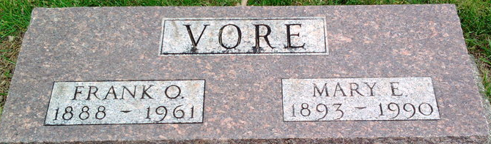
Photo by Thomas Liby

Hary Ellen Vore
in the Indiana, U.S., Death Certificates, 1899-2017
Name Mary Ellen Vore
[Mary Ellen Cupp]
Gender Female
Race White
Marital Status Widowed
Age 96
Birth Date 22 Aug 1893
Birth Place Bluffton, Indiana
Death Date 9 Jul 1990
Death Place Bluffton, Wells, Indiana, USA
Death Registration Date 1990
Father John Cupp
Mother Christina Jane Crosby
Spouse Franklin O Vore; deceased
Informant Stella Benzinger; friend; Keystone, Indiana
Burial July 12, 1990; Elm Grove Cemetery; Bluffton, Indiana

