Lulu S. (Witzenman) Vore
September 26, 1897 – November 10, 1993

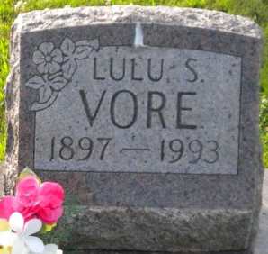
Photo by PLGS

Lulu S Vore
in the Indiana, U.S., Death Certificates, 1899-2017
Name Lulu S Vore
[Lulu S Witzenman]
Gender Female
Race White
Marital Status Widowed
Age 96
Birth Date 26 Sep 1897
Birth Place Leesburg In,
Death Date 10 Nov 1993
Death Place Warren, Huntington, Indiana, USA
Death Registration Date 1993
Father Adolph Witzenman
Mother Emilie Meyer
Informant Philip E. Souder; Adm.; Warren, Indiana
Burial November 12, 1993; Elm Grove Cemetery; Bluffton, Indiana

