Lawrence H. Vore
March 18, 1922 – January 5, 1927

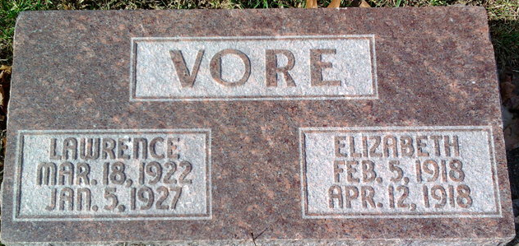
Photo by Thomas Liby

Lawrence Henry Vare
in the Indiana, U.S., Birth Certificates, 1907-1944
Name Lawrence Henry Vore
Gender Male
Birth Date 18 Mar 1922
Birth Place Bluffton, Wells, Indiana, USA
Father Mont S. Vore; age 27
Mother Elsie L Fisher; age 22; 4th child, all living
Certificate Number 16636
Roll number 40474_357252
Volume Range 31 - 35

**
Indiana, U.S., Death Certificates, 1899-2017
Name Laurence Henry Vore
Gender Male
Race White
Age 4
Birth Date 20 [sic] Mar 1922
Birth Place Indiana
Death Date 5 Jan 1927
Death Place Warren, Huntington, Indiana, USA
Death Registration Date 1926-1927
Father Monte Vore
Mother Elsie Fisher
Informant Elsie Vore; Warren, Indiana
Burial January 8, 1927; Elm Grove Cemetery

