John H. Vore
September 6, 1836 – July 25, 1922

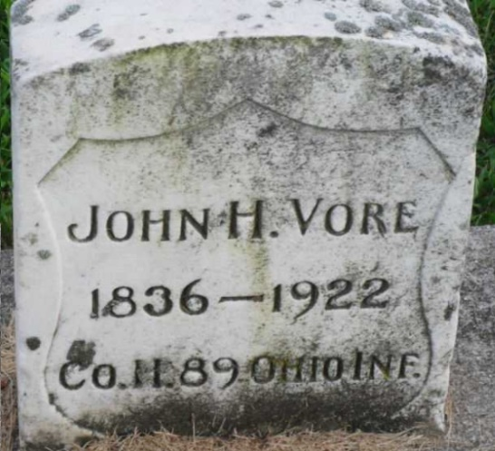
Photo by PLGS

John H. Vore
in the Indiana, U.S., Death Certificates, 1899-2017
Name John H. Vore
Gender Male
Race White
Marital Status Widow
Age 85
Birth Date 6 Sep 1836
Birth Place Guernsey Co Ohio
Death Date 25 Jul 1922
Death Place Bluffton, Wells, Indiana, USA
Death Registration Date 1922
Father Thomas Vore
Mother Ann Crook
Spouse Jane Crook
Informant Frank Vore; Fort Wayne, Indiana
Burial July 27, 1922; Elm Grove Cemetery

