Geraldine D. (Walters) Vore
April 20, 1915 – February 18, 1991

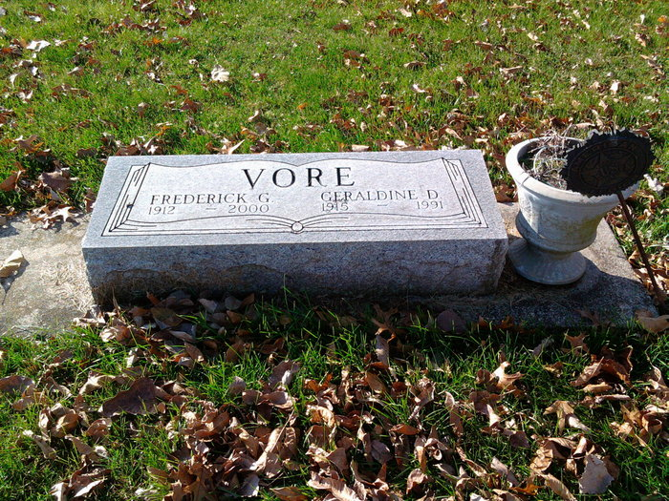
Photo by Thomas Liby

Geraldine D Vore
in the Indiana, U.S., Death Certificates, 1899-2017
Name Geraldine D Vore
[Geraldine D Walters]
Gender Female
Race White
Marital Status Married
Age 75
Birth Date 20 Apr 1915
Birth Place North Manchester, Indiana
Death Date 18 Feb 1991
Death Place Murray, Wells, Indiana, USA
Death Registration Date 1991
Father John Lloyd Walters
Mother Hazel Fausnaugh
Spouse Fred C Vore
Informant Fred Vore; husband; Bluffton, Indiana
Burial February 21, 1991; Elm Grove Cemetery; Bluffton, Indiana

