Frederick G. Vore
February 19, 1912 – May 28, 2000

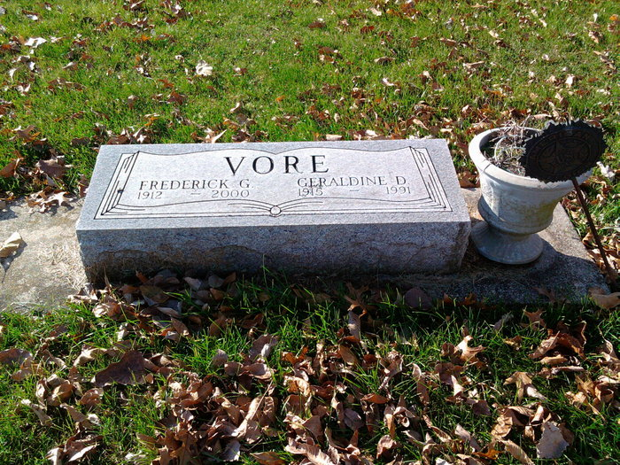
Photo by Thomas Liby

Vare
in the Indiana, U.S., Birth Certificates, 1907-1944
Name Vore; not legitimate
Gender Male
Birth Date 19 Feb 1912
Birth Place Bellville, Hendricks, Indiana, USA
Father Harry Shafer; age 24
Mother Jennie Vore; age 18; 1st child
Certificate Number 18258
Roll number 40474_357942
Volume Range 515 - 521
**
Indiana, U.S., Death Certificates, 1899-2017
Name Frederick G. Vore
Gender Male
Race White
Marital Status Widowed
Age 88
Birth Date 19 Feb 1912
Birth Place Hendricks County, Indiana
Death Date 28 May 2000
Death Place Bluffton, Wells, Indiana, USA
Death Registration Date 1998
Father Frank Vore [sic - grandfather/foster]
Mother Rachel Vore [sic - grandmother/foster]
Informant Don Vore; son; Bluffton, Indiana
Burial June 2, 2000; Elm Grove Cemetery; Bluffton, Indiana

