Franklin O. Vore
August 31, 1888 – February 26, 1961

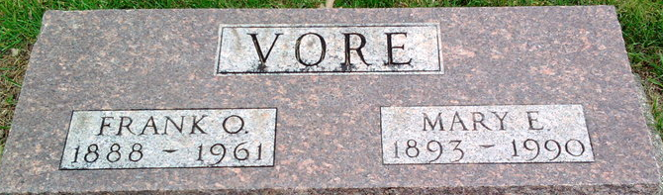
Photo by Thomas Liby

Franklin C Vore
in the Indiana, U.S., Death Certificates, 1899-2017
Name Franklin C Vore
Gender Male
Race White
Marital Status Married
Age 72
Birth Date 31 Aug 1888
Birth Place Indiana
Death Date 26 Feb 1961
Death Place Bluffton, Wells, Indiana, USA
Death Registration Date 1961
Father Frank C Vore
Mother Rose Jackson
Informant Mrs. Mary Vore; wife; Bluffton, Indiana
Burial March 1, 1961; Elm Grove Cemetery; Bluffton, Indiana

