Frank C. Vore
February 18, 1867 – February 24, 1940

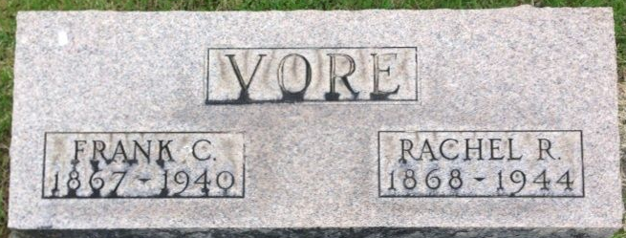
Photo by Thomas Liby

Frank C Vore
in the Indiana, U.S., Death Certificates, 1899-2017
Name Frank C Vore
Gender Male
Race White
Marital Status Married
Age 73
Birth Date 18 Feb 1867
Birth Place Mercer County, Ohio
Death Date 24 Feb 1940
Death Place Bluffton, Wells, Indiana, USA
Death Registration Date 1940
Father John H Vore
Mother Susana Jane Crook
Spouse Rachel R Jackson
Informant Mrs. Frank Vore; Bluffton, Indiana
Burial February 26, 1940; Elm Grove Cemetery; Bluffton, Indiana

