Elizabeth Jane Vore
February 5, 1918 – April 23, 1918

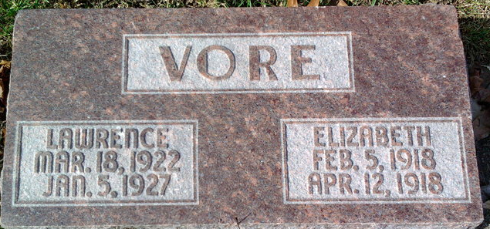
Photo by Thomas Liby

Elizabeth Jane Vare
in the Indiana, U.S., Death Certificates, 1899-2017
Name Elizabeth Jane Vore
Gender Female
Race White
Marital Status Single
Age 0
Birth Date 5 Feb 1918
Birth Place Warren, Indiana
Death Date 23 Apr 1918
Death Place Bluffton, Wells, Indiana, USA
Death Registration Date 1918
Father Monte Vore
Mother Elsie Fisher
Informant Monte Vore; Bluffton, Indiana
Burial April 24, 1918; Elm Grove Cemetery

