Billy Vore, Jr.
October 18, 1925 – October 18, 1925

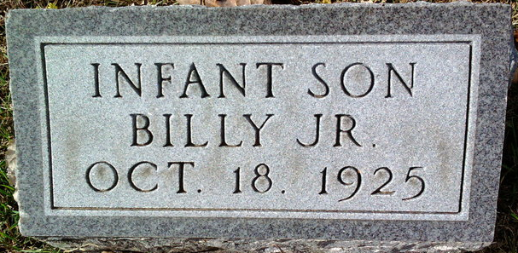
Photo by Thomas Liby

Billy Vore in tree HARRIS - 1
Father Nile Harold Vore
Mother Mildred Etta Shady
Birth 18 Oct 1925 Bluffton, Wells, Indiana, USA
Death 18 Oct 1925 Bluffton, Wells, Indiana, USA

