Orra Neil Vondersmith
June 8, 1896 – April 5, 1948

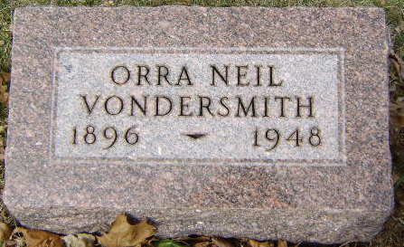
Photo by Bruce Sonner

Neil Vondersmith
in the Indiana, U.S., Death Certificates, 1899-2017
Name Neil Vondersmith
Gender Male
Race White
Marital Status Married
Age 51
Birth Date 8 Jun 1896
Birth Place Remington, Indiana
Death Date 5 Apr 1948
Death Place Rural, Wells, Indiana, USA
Death Registration Date 1948
Father Edward Vondersmith
Mother Lillie Dewey
Spouse Carrie Cochran
Informant Orpha Vondersmith; Bluffton, Indiana
Burial April 8, 1948; Elm Grove Cemetery; Bluffton, Indiana

