Harold D. Vondersmith
March 5, 1921 – September 29, 1946

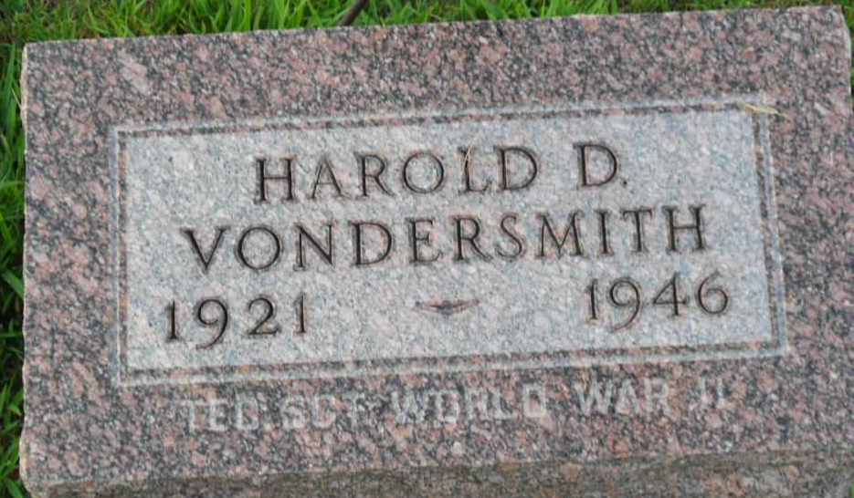
Photo by PLGS

Harold D Vondersmith
in the Indiana, U.S., Birth Certificates, 1907-1944
Name Harold D Vondersmith
Gender Male
Birth Date 5 Mar 1921
Birth Place Harrison, Wells, Indiana, USA
Father Neil Vondersmith; age 23
Mother Cary Cochran; age 22; 2nd child; both living
Certificate Number 17293
Roll number 40474_356368
Volume Range 31 - 36

**
Indiana, U.S., Death Certificates, 1899-2017
Name Harold D Vondersmith
Gender Male
Race White
Marital Status Single
Age 25
Birth Date 5 Mar 1921
Birth Place Indiana
Death Date 29 Sep 1946; auto accident
Death Place Bluffton, Wells, Indiana, USA
Death Registration Date 1946
Father Neal Vondersmith
Mother Carie Cochran
Informant Neal Vondersmith; Bluffton, Indiana
Burial October 2, 1946; Elm Grove Cemetery; Bluffton, Indiana

