Carrie (Cochran) Vondersmith
July 8, 1898 – May 2, 1968

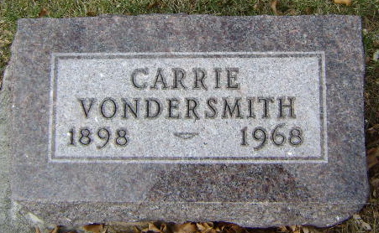
Photo by Bruce Sonner

Carrie Vandersmith
in the Indiana, U.S., Death Certificates, 1899-2017
Name Carrie Vandersmith
[Carrie Cochran]
Gender Female
Race White
Marital Status Widowed
Age 69
Birth Date 8 Jul 1898
Birth Place Indiana
Death Date 2 May 1968
Death Place Marion, Grant, Indiana, USA
Death Registration Date 1968
Father Benton Cochran
Mother Lucy Rose
Informant Wilma Foster; daughter; Bluffton, Indiana
Burial May 4, 1968; Elm Grove Cemetery; Bluffton, Indiana

