Jamie Lyn (Haynie) Vitz
March 31, 1976 -

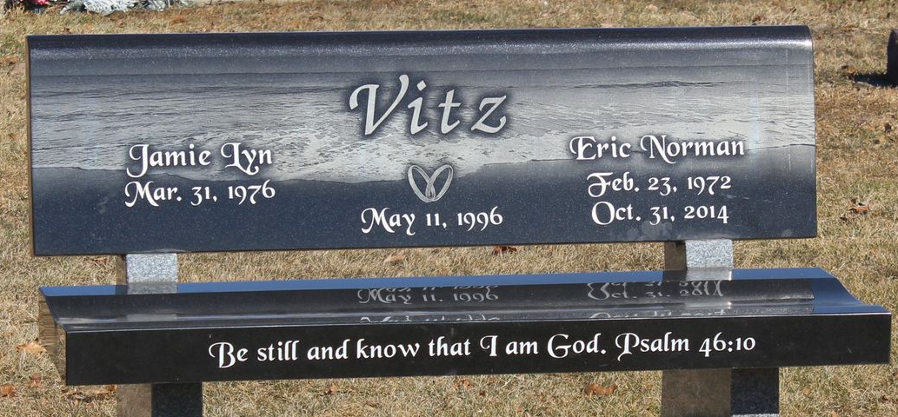
Photo by Tombstoner & Family

