Eric Norman Vitz
February 23, 1972 – October 31, 2014

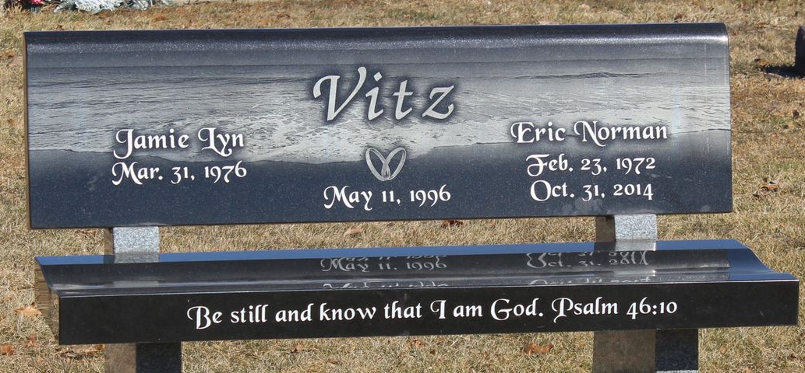
Photo by Tombstoner & Family

Eric Norman Vitz, 42, of Bluffton passed away on Friday morning at Lutheran Hospital in Fort Wayne of complications from Endocarditis & subsequent brain trauma.
Eric was born on February 23, 1972 in Elyria, Ohio to Norman & Doreen (Lakey-Hoyt) Vitz. He graduated from Vestaburg High School in 1990. He went on to attend Baker College and graduated from Great Lakes Christian College in 1995 earning a Bachelor of Religious Education with a focus on Christian Ministry. He completed his master’s in professional communication from Purdue University.
He worked at Medical Protective in Fort Wayne, Inventure Foods in Bluffton, served as Director of Virtual Campus at Trine University, and was the Director of Distance Learning at I.P.F.W. He was an active member of the First Church of Christ in Bluffton where he served as an elder, drama ministry participant, small group leader and helped with multimedia. He also filled in preaching occasionally as he would say, “just for kicks and giggles.”
On May 11, 1996 in Charlotte, Michigan, Eric and Jamie (Haynie) were married.
He is survived by his wife along with three girls: Claudia - 14, Ellie - 12 and Sydney – 10, all of Bluffton. Other survivors include his mother, Doreen Porter, of Greenwood, Indiana and siblings; Debra (Howard) Marks of CA., Nancy (Tom) Witt of Avon, IN, John Ballas, Lori (Steve) Burke, Kathy Ballas, Sue (Tom) Tappenden, Jeff Ballas all of Michigan, Scott (Sara) Vitz of Leo, IN, Kelly (Lisa Saunders) Vitz of MI., and Crystal Porter of Greenwood, IN.
Eric will be remembered as living a life that brought joy and laughter to all who knew him. He loved his family and friends and was adored by many for his quick wit and infectious laugh. He intentionally chose to make the most out of the life he was given and tried to make the lives of those around him brighter. His passing has left a tremendous wound, but his steadfast faith and walk with Christ leave no doubt that he is at home with his Redeemer. We imagine the angels rolling with laughter on the streets of gold.
A service to celebrate Eric’s life will be held at 10:30 on Wednesday (November 5, 2014) at First Church of Christ in Bluffton. Ministers Larry Sprinkle and Tom Haynie will officiate. Calling Hours will be held from 2 to 8 on Tuesday at the Thoma/Rich, Lemler Funeral Home in Bluffton, with additional calling for one hour prior to the service at the church. Burial will follow at Elm Grove Cemetery in Bluffton. Memorials may be made in Eric’s memory to a fund for his daughters’ educations with checks payable to Jamie Vitz.

Thoma/Rich Funeral Home, Wells County, Indiana
November 1, 2014

