Omer Joseph Viau
January 21, 1907 – April 23, 1946

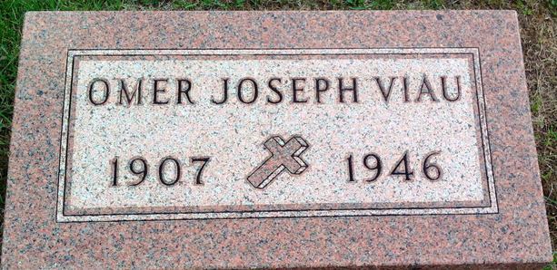
Photo by Thomas Liby

Omar Joseph Viau in Viau Family tree
Spouse Irene May Cole
Father Adelard Joseph Viau
Mother Cordelia Petre
Birth 21 Jan 1907 Northland, Marquette, Michigan, USA
Death 23 Apr 1946 Allen Park, Wayne, Michigan, USA
Residence 1930 Chicago, Cook, Illinois, USA

