J. Willetta (Haskell) Vestal
April 9, 1884 - May 30, 1971

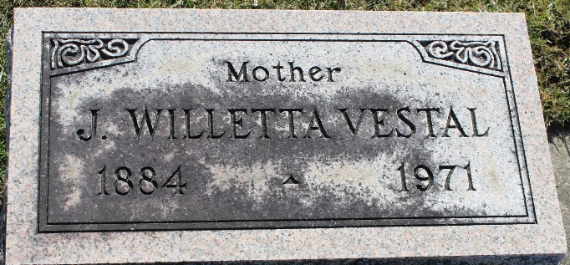
Photo by Tombstoner & Family

Mrs. J. Willetta Vestal, 87, of Ossian, Route 1 died Sunday in Lutheran Hospital. She had been a schoolteacher.
She was the widow of Jesse L. Vestal. A member of the Ossian United Methodist Church.
Surviving is one daughter, Mrs. Howard Smith of Ossian, Route 1, a granddaughter and three great-grandchildren.
The services will be held in Elzey Funeral Home at Ossian. Rev. Harold Schram officiating. Burial will be at Elm Grove Cemetery, Bluffton.

Bluffton News-Banner, Wells County, Indiana
May 31, 1971

**
Indiana, U.S., Death Certificates, 1899-2017
Name J Willetta Vestal
[J Willetta Haskell]
Gender Female
Race White
Marital Status Widowed
Age 87
Birth Date 9 Apr 1884
Birth Place Kansas
Death Date 30 May 1971
Death Place Fort Wayne, Allen, Indiana, USA
Death Registration Date 1971
Father Benjamin Haskell
Mother Tennessee Hyden
Informant Mrs. Howard Smith; daughter; Ossian, Indiana
Burial June 1, 1971; Elm Grove Cemetery; Bluffton, Indiana

