Jesse L. Vestal
May 26, 1881 – February 10, 1939

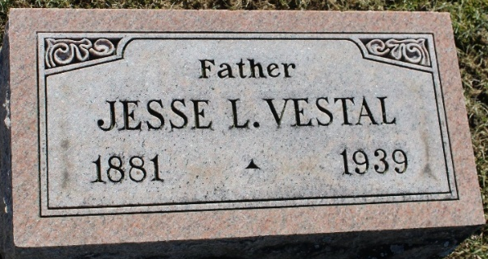
Photo by Tombstoner & Family

VESTAL

Funeral services for Jesse L. Vestal, 57, well-known farmer living three and one-half miles west of Yoder in Lafayette Township, who died of a kidney infection at 4:30 o’clock Friday morning at the Lutheran Hospital, will be held Monday afternoon at 2 o’clock at the residence, Rev. N. E. Gilliland of Zanesville officiating. Burial will be in Elm Grove Cemetery at Bluffton. The body was taken to Elzey & Sons Funeral Home in Ossian and will be returned to the residence tonight.
The deceased had been a patient at the hospital for three weeks.
Survivors include the widow; a daughter, Mrs. Howard R. Smith of near Roanoke; two brothers, Gilbert of Des Moines, Iowa and Clare Vestal of Dolton, Illinois, and a sister, Mrs. Claude Baldwin of My Ayr.

Journal-Gazette, Allen County, Indiana
February 11, 1939

**
Indiana, U.S., Death Certificates, 1899-2017
Name Jesse L. Vestal
Gender Male
Race White
Marital Status Married
Age 57
Birth Date 26 May 1881
Birth Place Indiana
Death Date 10 Feb 1939
Death Place Fort Wayne, Allen, Indiana, USA
Death Registration Date 1939
Father William Vestal
Mother Jane Barton
Spouse Willette Haskell
Informant Mrs. Willette Vestal; Ossian, Indiana
Burial February 13, 1939; Elm Grove Cemetery; Bluffton, Indiana

