Naomi (Milstead) Kline-Vernon
December 18, 1916 – November 9, 2002

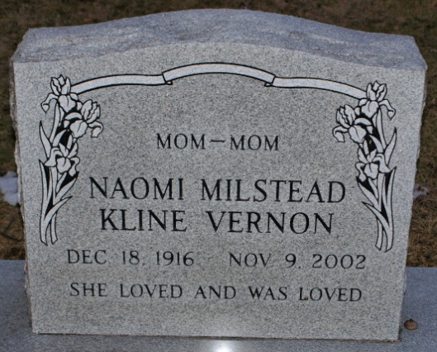
Photo by PLGS

Naomi M. Vernon, 85, a resident of Fort Wayne 1975 and mother-in-law of Rev. Walter Graeflin of Bluffton died at 1:01 pm Saturday, November 9 at Parkview Hospital in Fort Wayne. Mrs. Vernon was a resident of the Arbor Gleen Retirement Center in Fort Wayne.
She was an employee of the federal government for nine years and was a member of the First Church of the Nazarene in Bluffton for many years.
Surviving in addition to her son-in-law are three sons, Ronald Kline of Longwood, Florida, David Kline of Whetstone, Arizona and Gary Kline of Lake Ariel, Pennsylvania; nine grandchildren; 10 great grandchildren and four great-great grandchildren. A daughter, Iris Graeflin, three brothers and five sisters are deceased.
A graveside service will be at 11:30 am Tuesday at Elm Grove Cemetery with Rev. Graeflin officiating.
Memorials to WBCL Christian Radio.
Bluffton News Banner, Wells County, Indiana
November 11, 2002

**
Indiana, U.S., Death Certificates, 1899-2017
Name Naomi M Vernon
[Naomi M Milstead]
Gender Female
Race White
Marital Status Divorced
Age 85
Birth Date 18 Dec 1916
Birth Place Charles County, Maryland
Death Date 9 Nov 2002
Death Place Fort Wayne, Allen, Indiana, USA
Death Registration Date 2002
Father Vivian Milstead
Mother Catherine Bowie
Informant Ronald Kline; son; Longwood, Florida
Burial November 12, 2002; Elm Grove Cemetery; Bluffton, Indiana

**
Virginia, U.S., Select Marriages, 1785-1940

Name Naomi Milstead
Gender Female
Marital Status Single
Age 21
Birth Date 1910
Birth Place Indian Head, MD
Marriage Date 22 Dec 1931
Marriage Place Manassas, Prince William, Virginia
Father Vivian Milstead
Mother Catherine Bowie
Spouse George E. Kline
FHL Film Number 33138
Reference ID 83

