John William Vernon
July 3, 1860 – May 27, 1913

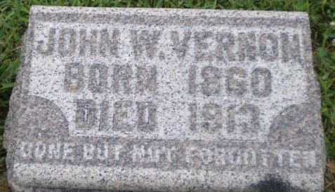
Photo by PLGS

John William Vernon
in the Indiana, U.S., Death Certificates, 1899-2017
Name John William Vernon
Gender Male
Race White
Marital Status Married
Age 52
Birth Date 3 Jul 1860
Birth Place Indiana
Death Date 27 May 1913
Death Place Bluffton, Wells, Indiana, USA
Death Registration Date 1913
Father Ira Vernon
Mother Emely Miles
Spouse Almeda Tharp
Informant Mrs. J. W. Vernon; Bluffton, Indiana
Burial May 29, 1913; Elm Grove Cemetery

