Almeda R. (Tharp) Vernon
October 4, 1859 – June 16, 1946

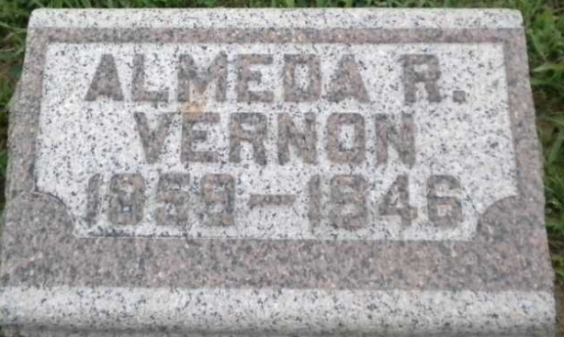
Photo by PLGS

Almeda R Vernon
in the Indiana, U.S., Death Certificates, 1899-2017
Name Almeda R Vernon
[Almeda R Tharp]
Gender Female
Race White
Age 86
Birth Date 4 Oct 1859
Birth Place Mercer County, Ohio
Death Date 16 Jun 1946
Death Place Rural, Wells, Indiana, USA
Death Registration Date 1946
Father William Tharp
Mother Lucy Woodward
Spouse John W Vernon
Informant Mrs. Ora Bolsley; Bluffton, Indiana
Burial June 18, 1946; Elm Grove Cemetery; Bluffton, Indiana

