Turner Vaughn
1852 – December 6, 1928

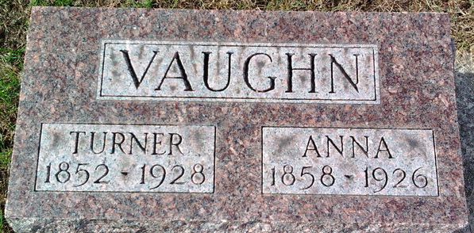
Photo by Thomas Liby

Turner Vaughn
in the Indiana, U.S., Death Certificates, 1899-2017
Name Turner Vaughn
Gender Male
Race White
Marital Status Widow
Age 77
Birth Date 1851
Birth Place Ohio
Death Date 6 Dec 1928
Death Place Lancaster, Wells, Indiana, USA
Death Registration Date 1928
Parents Unknown
Spouse Anna Ward
Informant Joseph Call; Craigville, Indiana
Burial December 8, 1928; Elm Grove Cemetery

**
Turner S. Vaughn from Bennett Family Tree
Spouse Artansa Anne Ward Vaughn
Father Joseph Vaughn
Mother Rachel Shuman Vaughn
Children Minnie Laverne
Birth Jan 1852 Guernsey, Ohio, USA
Death 6 Dec 1928 Wells, Indiana, USA
Residence About 1918 Indiana, USA

