Shawn M. Vaughn, Jr.
December 3, 2016 – December 3, 2016

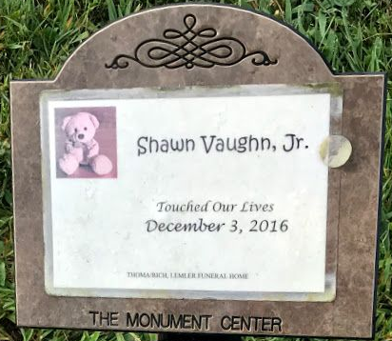
Photo by SMMR

Shawn M. Vaughn, Jr. touched his families’ lives on Saturday, December 3, 2016, at Lutheran Hospital in Fort Wayne. Shawn was born on December 3, 2016 in Fort Wayne to Amanda M. Gatto and Shawn M. Vaughn, Sr.
He is survived by his parents of Bluffton along with siblings: Desirae Gatto, Audrina Stuller, Alainah Gatto, Vanessa Gatto, Cristian James Vaughn and Keon Falk. He is also survived by two grandmothers; Lisa Penrod of Montpelier and Vera Vaughn of Bluffton.
Shawn is preceded in death by a sister Harper Ann Crispen on December 13, 2014.
A graveside service will be held at 3:00 p.m. on Wednesday, December 7, 2016, in the Garden of the Chimes located in Elm Grove Cemetery. Msgr. Pius N. Ilechukw will officiate.
Memorials may be made in Shawn’s memory to the family.

Thoma/Rich Funeral Home, Wells County, Indiana
December 4, 2016

