Jerry Lee Vaughn
July 5, 1933 – February 21, 1995

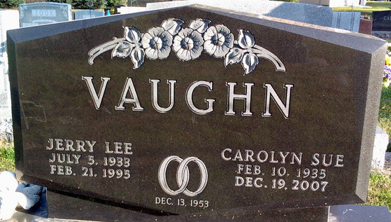
Photo by Thomas Liby

Jerry L Vaughn
in the Indiana, U.S., Death Certificates, 1899-2017
Name Jerry L Vaughn
Gender Male
Race White
Marital Status Married
Age 61
Birth Date 5 Jul 1995 [sic]
Birth Place Wells County, Indiana
Death Date 21 Feb 1995
Death Place Auburn, DeKalb, Indiana, USA
Death Registration Date 1995
Father Alvin Vaughn
Mother Anna Van Camp
Spouse Sue Carnes
Informant Sue Vaughn; wife; Bluffton, Indiana
Burial February 24, 1995; Elm Grove Cemetery; Bluffton, Indiana

