Eric Paul Vaughn
December 24, 1956 – August 27, 2011

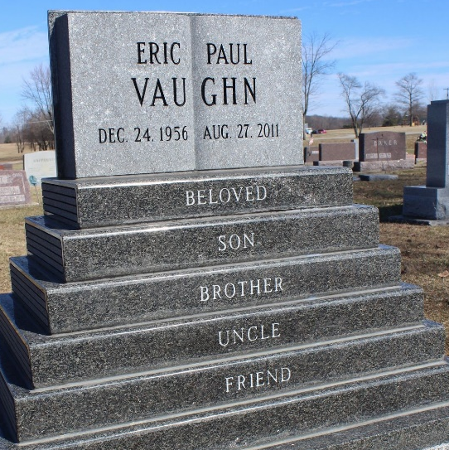
Photo by Tombstoner & Family

Eric Paul Vaughn
in the Virginia, U.S., Death Records, 1912-2014
Name Eric Paul Vaughn
Death Date 27 Aug 2011
Death Place Fairfax, Virginia, USA
**
U.S., Social Security Death Index, 1935-2014
Name Eric P. Vaughn
Social Security Number xxx
Birth Date 24 Dec 1956
Issue year 1972
Issue State Indiana
Last Residence 47421, Bedford, Lawrence, Indiana
Death Date 27 Aug 2011

