Carolyn Sue (Carnes) Vaughn
February 10, 1935 – December 19, 2007

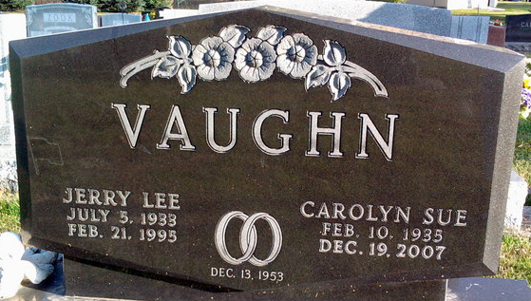
Photo by Thomas Liby

Carolyn "Sue" Vaughn, 72, of Bluffton, died at 12:10 p.m. Wednesday, Dec. 19, 2007 at Bluffton Regional Medical Center.Born in Wells County to Everett W. and Mable Chloe (Walker) Carnes on Feb. 10, 1935, she married Jerry Vaughn in Wells County on Dec. 13, 1953; he preceded her in death on Feb. 21, 1995.
A 1953 graduate of Chester Center School, Mrs. Vaughn worked as a realtor in Bluffton, serving for five years with Vore Real Estate and 15 years with BKM. Real Estate. She was a member of the Bluffton Bridge Club for more than 20 years and also a member of the First Church of Christ.
Surviving relatives include two daughters, Terry (Ked) Biberstine of Markle and Sandy (Kurt) Reiners of Elkhart; one son, Scott (Adrian) Vaughn of Fishers; three sisters, Yvonne Loftin of Shreveport, La., Monnah Raber of Bluffton and Berthetta Chaney of Fort Wayne; and five grandchildren. Mrs. Vaughn was preceded in death by a brother, Jack Carnes, and a sister, Mary Myers.
Funeral services will be at 3 p.m. Saturday, at the Thoma/Rich, Chaney & Lemler Funeral Home in Bluffton, with Pastor Larry Sprinkle officiating. Calling hours will be from noon to 3 p.m. Saturday at the funeral home. Burial is at Elm Grove Cemetery, in Bluffton.
Preferred memorials are to the charity of the donor's choice.

Thoma/Rich Funeral Home, Wells County, Indiana
December 20, 2007

