Anna M. (Van Camp) Vaughn
October 17, 1903 – February 3, 1997

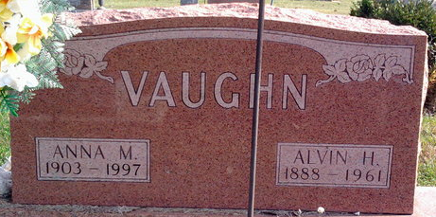
Photo by Thomas Liby

Anna May Vaughn
in the U.S., Social Security Applications and Claims Index, 1936-2007
Name Anna May Vaughn
[Anna May Vancamp]
Gender Female
Race White
Birth Date 17 Oct 1903
Birth Place Poneto Wells, Indiana
Death Date 3 Feb 1997
Father William W Vancamp
Mother Emma C Harris
SSN xxx
Notes Apr 1941: Name listed as ANNA MAY VAUGHN; 14 Feb 1997: Name listed as ANNA M VAUGHN
**
Texas, U.S., Death Index, 1903-2000
Name Anna Vaughn
Death Date 3 Feb 1997
Death County Dallas
Gender Female

