Alvin Harrison Vaughn
July 13, 1888 – May 30, 1961

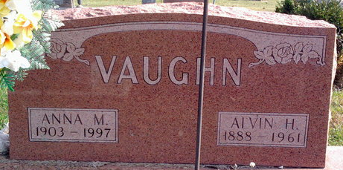
Photo by Thomas Liby

Alvin Harrison Vaughn
in the Indiana, U.S., Death Certificates, 1899-2017
Name Alvin Harrison Vaughn
Gender Male
Race White
Marital Status Married
Age 72
Birth Date 13 Jul 1888
Birth Place Indiana
Death Date 30 May 1961
Death Place Bluffton, Wells, Indiana, USA
Death Registration Date 1961
Father Turner Vaughn
Mother Anna Ward
Informant Mrs. Alvin Vaughn; wife; Bluffton, Indiana
Burial June 3, 1961; Elm Grove Cemetery; Bluffton, Indiana

