Artansa A. “Anna” (Ward) Vaughn
May 1, 1858 – January 14, 1926

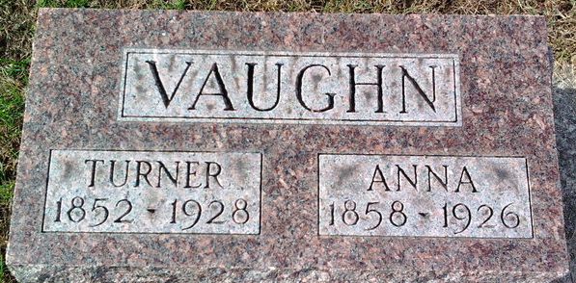
Photo by Thomas Liby

Anna Ward Vanghan
in the Indiana, U.S., Death Certificates, 1899-2017
Name Anna Ward Vaughn
[Anna Ward]
Gender Female
Race White
Marital Status Married
Age 67
Birth Date 1 May 1858
Birth Place Warren County, Ohio
Death Date 14 Jan 1926
Death Place Bluffton, Wells, Indiana, USA
Death Registration Date 1926-1927
Father John Ward
Mother Unknown
Spouse Turner Vaughn
Informant Turner Vaughn; Bluffton, Indiana
Burial January 17, 1926; Elm Grove Cemetery

**
Artansa A “Ann” WARD from tree Murray Family Tree (working tree)
Birth 1 May 1858 Warren, Indiana, USA
Marriage 21 Feb 1880 Wells, Indiana, USA
Residence 1920 Bluffton, Wells, Indiana, USA
Death 14 Jan 1926 Bluffton, Wells, Indiana, USA
Father John Thomas Ward (1818-1882)
Mother Sarah Ann Bates (1825-1893)
Spouse Turner S Vaughn (1852-1928)

