Verna E. (Brumbaugh) Vaughan
February 25, 1898 – January 20, 1987

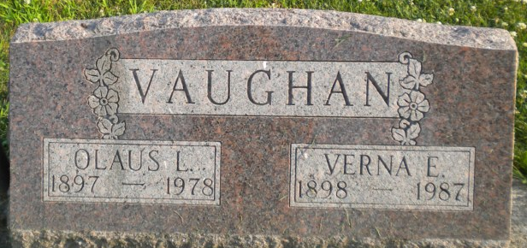
Photo by PLGS

Venna E Vaughan
in the Indiana, U.S., Death Certificates, 1899-2017
Name Verna E Vaughan
[Verna E Brumbaugh]
Gender Female
Race White
Marital Status Widowed
Age 88
Birth Date 25 Feb 1898
Birth Place Indiana
Death Date 20 Jan 1987
Death Place Fort Wayne, Allen, Indiana, USA
Death Registration Date 1987
Father Charles Brumbaugh
Mother Lydia Gilbert
Informant John R. May; guardian; Fort Wayne, Indiana
Burial January 22, 1987; Elm Grove Cemetery; Bluffton, Indiana

