Olaus Lowell Vaughan
July 13, 1897 – January 7, 1978

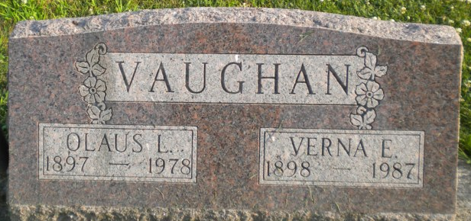
Photo by PLGS

Olaus Lowell Vaughan
in the Florida, U.S., Death Index, 1877-1998
Name Olaus Lowell Vaughan
Race White
Age at Death 80
Birth Date 13 Jul 1897
Death Date 7 Jan 1978
Death Place Brevard, Florida, United States
**
Indiana, U.S., Marriage Certificates, 1960-2012
Name Olaus L Vaughan
Gender Male
Race White
Marriage Age 38
Birth Date 13 Jul 1897
Marriage License Date 10 Jul 1936
Marriage Date 11 Jul 1936
Marriage Place Allen, Indiana, USA
Residence Place Fort Wayne, Indiana
Father Linus T Vaughan
Mother Minnie E Vaughan
Spouse Verna E Marshall
Other Person Harold F Ricketts
Officiator W E Smith

