Marilyn Suzanne (Higgins) Vanden Top
October 2, 1940 – November 20, 2020

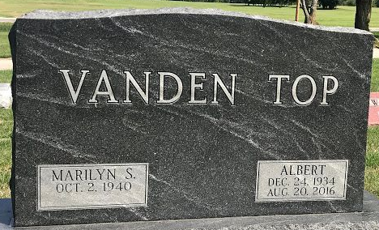
Photo by SMMR

Marilyn Suzanne Vanden Top, 80 of Warren, and longtime resident of Bluffton, passed away on Friday afternoon, November 20, 2020, at Heritage Pointe in Warren. Marilyn was born on October 2, 1940 in Bluffton to Garth & Evelyn (Arnold) Higgins.
She graduated from Bluffton High School in 1958, and graduated from International Business College.
After being pen pals, Marilyn and Albertus “Al” Vanden Top were married on April 2, 1961. They lived a short time in Ontario, Canada, then moved home to Bluffton. In 1990 they moved to Cherry Hill, New Jersey and Stamford, Connecticut, returning to Bluffton in 1999.
Al preceded her in death on August 20, 2016.
Marilyn was a lifelong seamstress, patching knees on her boys’ worn-out pants to elegant wedding dresses. She also became an EMT, then a Medical Transcriptionist for Wells Community Hospital and Bluffton Regional Hospital. She loved baking especially for family and church gatherings, and canned anything that would fit in a jar. You could find her on any 90-degree humid August Saturday afternoon, in her kitchen with two canners going on the stove.
She and Al loved attending their grandchildren’s sporting events and taking them out for ice cream. She loved her grandchildren and gazing at the stars. Any day of the week, Marilyn would selflessly choose to help others, before ever doing something for herself.
She was an active member of the First United Methodist Church in Bluffton, and Zanesville United Methodist Church.
Survivors include a son Thomas (Heather) G. Vanden Top of Yoder, daughter-in-law Rhonda Vanden Top of Bluffton along with five grandchildren; Hannah and Andrea Vanden Top, Grace, August and Eli Vanden Top, along with her brother Edward “Ed” Higgins of Bluffton. Marilyn is preceded in death by her parents, husband Al, and son James “Jimmy” Vanden Top on December 20, 2007.
Funeral services will be held at 10:30 A.M. on Wednesday, with Pastor Dick Case officiating. Burial will follow at Elm Grove in Bluffton.

Thoma/Rich Funeral Home, Wells County, Indiana
November 21, 2020

