Ethel J. (Fuller) VanHorn
1881 – March 3, 1972

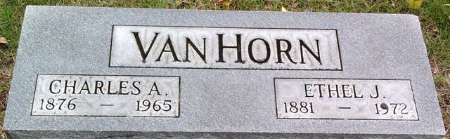
Photo by Thomas Liby

Ethel J. Fuller
in the Ohio, U.S., County Marriage Records, 1774-1993
Name Ethel J. Fuller
Gender Female
Marriage Age 21
Birth Date abt 1882
Marriage Date 6 May 1903
Marriage Place Defiance, Ohio, USA
Father J.A. Fuller
Mother Katheryn I. Strong
Spouse Charles A. Van Horn
Film Number 000909339

**
Ohio, U.S., Death Records, 1908-1932, 1938-2022
Name Ethel J Vanhorn
Gender Female
Race White
Marital Status Widowed
Death Age 90
Birth Date Abt 1882
Residence Place Paulding, Ohio, USA
Death Date 3 Mar 1972
Death Place Bryan, Williams, Ohio, USA
Certificate Number 025335
Inquest Hospital Williams Comm Gen Bryan
Inquest Questions Certifier: Physician; Autopsy Performed?: No Autopsy Performed;

