Charles A. VanHorn
December 5, 1876 – November 8, 1965

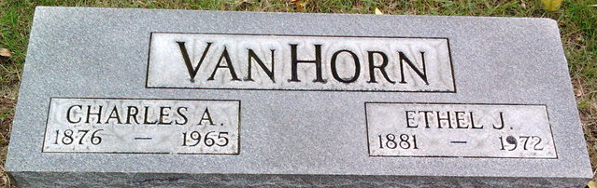
Photo by Thomas Liby

Charles A Van Horn
in the Ohio, U.S., County Marriage Records, 1774-1993
Name Charles A Van Horn
Gender Male
Marriage Age 26
Birth Date abt 1877
Marriage Date 6 May 1903
Marriage Place Defiance, Ohio, USA
Father John Van Horn
Mother Elizabeth Grove
Spouse Ethel J Fuller
Film Number 001977641

**
Ohio, U.S., Death Records, 1908-1932, 1938-2022
Name Charles A Vanhorn
Gender Male
Race White
Marital Status Married
Death Age 88
Birth Date Abt 1877
Residence Place Paulding, Ohio, USA
Death Date 8 Nov 1965
Death Place Paulding, Ohio, USA
Certificate Number 86936
Inquest Hospital Home
Inquest Questions Certifier: Physician; Autopsy Performed?: Yes, Used For Certification;
**
U.S., Social Security Death Index, 1935-2014
Name Charles Vanhorn
Social Security Number xxx
Birth Date 5 Dec 1876
Issue year 1951-1952
Issue State Indiana
Death Date Nov 1965

