Carrie B. (Hower) Van Dine
April 10, 1889 – July 16, 1981

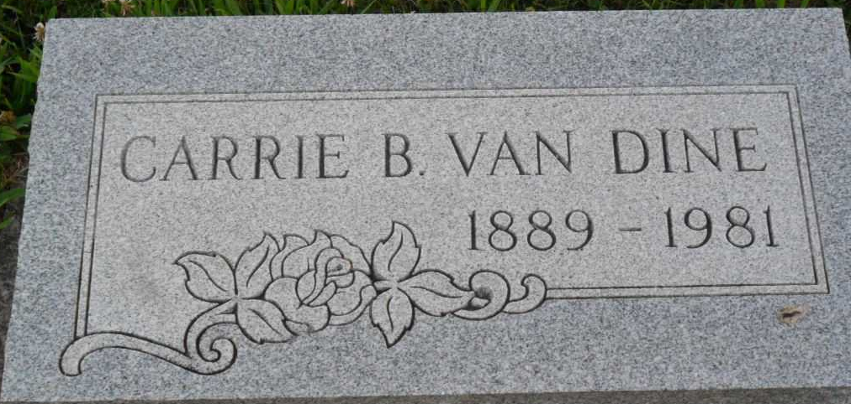
Photo by PLGS

Carrie B. Van Dine
in the Indiana, U.S., Death Certificates, 1899-2017
Name Carrie B. Van Dine
Gender Female
Race White
Marital Status Widowed
Age 92
Birth Date 10 Apr 1889
Birth Place Indiana
Death Date 16 Jul 1981
Death Place Warren, Huntington, Indiana, USA
Death Registration Date 1981
Father Noah Hower
Mother Ellen Clowser
Informant Philip Souder; Adm.; Warren, Indiana
Burial July 18, 1981; Elm Grove Cemetery; Bluffton, Indiana

