Wilma J. (Marshall) Valentine
September 22, 1937 – September 28, 2013

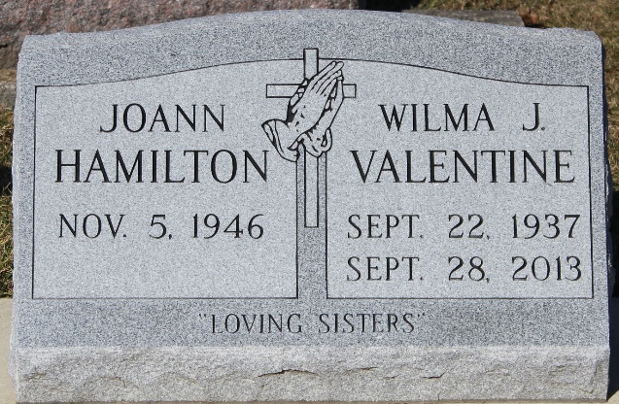
Photo by Tombstoner & Family

Wilma J. Valentine, 76, of Bluffton, passed away Saturday morning, September 28, 2013, at Kindred Nursing and Rehabilitation - Meadowvale.
A memorial service for Wilma will be held Tuesday, October 1, 2013, at 12:00 noon, at Goodwin - Cale & Harnish Memorial Chapel with Dr. Bryson E. Bell officiating. The family will also receive friends on Tuesday, for two hours prior to the service, from 10:00 a.m. until service time. Burial will take place at Elm Grove Cemetery at a later date.

Goodwin Funeral Home, Wells County, Indiana
September 29, 2013

**
Indiana, U.S., Death Certificates, 1899-2017
Name Wilma J Valentine
Maiden Name Marshall
Gender Female
Race White
Age 76
Birth Date 22 Sep 1937
Birth Place Poteau, Oklahoma
Death Date 28 Sep 2013
Death Place Bluffton, Wells, Indiana, USA
Death Registration Date 2013
Father Eston V. Marshall
Mother Evelyn Walker
Informant Joann Hamilton; sister; Bluffton, Indiana
Cremation Wilson Burial Vault; Huntington, Indiana
Certificate Number 045376

