Sarah Ellen (Risser) Valentine
October 19, 1874 – December 23, 1961

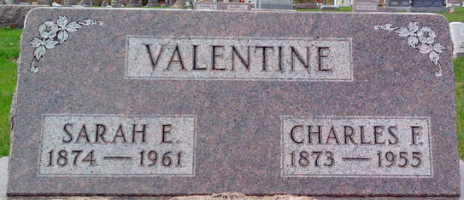
Photo by Thomas Liby

Sarah Ellen Valentine
in the Indiana, U.S., Death Certificates, 1899-2017
Name Sarah Ellen Valentine
[Sarah Ellen Risser]
Gender Female
Race White
Marital Status Widowed
Age 87
Birth Date 19 Oct 1874
Birth Place Wells County, Indiana
Death Date 23 Dec 1961
Death Place Fort Wayne, Allen, Indiana, USA
Death Registration Date 1961
Father Wm H Risser
Mother Mary Rose
Informant Rosie Valentine; son; Fort Wayne, Indiana
Burial December 26, 1961; Elm Grove Cemetery; Bluffton, Indiana

