Rosil L. Valentine
May 8, 1895 – May 3, 1977

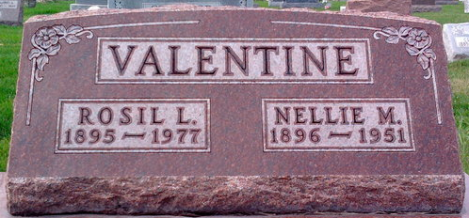
Photo by Thomas Liby

Rosil L. Valentine
in the Indiana, U.S., Death Certificates, 1899-2017
Name Rosil L. Valentine
Gender Male
Race White
Marital Status Married
Age 81
Birth Date 8 May 1895
Birth Place Indiana
Death Date 3 May 1977
Death Place Fort Wayne, Allen, Indiana, USA
Death Registration Date 1977
Father Charles Valentine
Mother Sarah Risser
Spouse Hazel Coulter
Informant Hazel Valentine; wife; Fort Wayne, Indiana
Burial May 6, 1977; Elm Grove Cemetery; Bluffton, Indiana

