Nellie Marie (Stahl) Valentine
September 6, 1896 – September 11, 1951

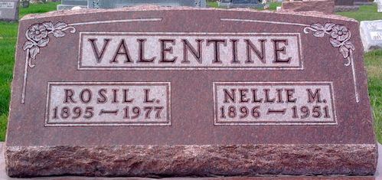
Photo by Thomas Liby

Nellie Marie Valentine
in the Indiana, U.S., Death Certificates, 1899-2017
Name Nellie Marie Valentine
[Nellie Marie Stahl]
Gender Female
Race White
Marital Status Married
Age 55
Birth Date 6 Sep 1896
Birth Place Wells County, Indiana
Death Date 11 Sep 1951
Death Place Fort Wayne, Allen, Indiana, USA
Death Registration Date 1951
Father Fred Stahl
Mother Minnie Weaver
Informant Rosil Valentine; Fort Wayne, Indiana
Burial September 14, 1951; Elm Grove Cemetery; Bluffton, Indiana

