Charles Franklin Valentine
July 27, 1873 – November 27, 1955

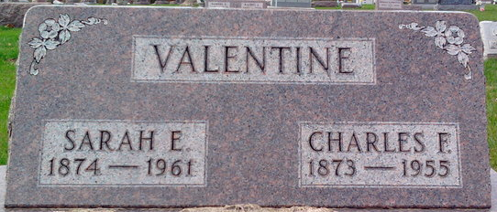
Photo by Thomas Liby

Charles Franklin Valentine was born July 27, 1873, in Wells County, Indiana, the son of Joseph E. and Catharine Leist Valentine. On August 4, 1894, in Wells County, Indiana, he married Sarah Ellen Risser, daughter of William and Mary A. Rose Risser.
They were the parents of 4 sons: Rosil L., Ralph A., Lewis and Wilfred Valentine. Charles passed away on November 28, 1955, in Ft. Wayne, Allen County, Indiana, and was buried on the 30th in Elm Grove Cemetery, in Bluffton, Wells County, Indiana.
Bluffton News Banner, Wells County, Indiana
November 28, 1955

**
Charles Valentine Dies at Fort Wayne

Charles Franklin Valentine, 82, a native of Wells County, died at 8:15 p.m. Sunday at the Parkview Memorial Hospital, Fort Wayne, shortly after he had been admitted there as a patient. His home was at 802 DeWald Street, that city.
The decedent had resided in Nottingham Township, Wells County, previously to locating in Fort Wayne in 1927. He was a member of the Odd Fellows Lodge at Petroleum. Mr. Valentine was a son of the late Joseph and Catherine Leist Valentine.
Surviving is the widow, Sarah A.; four sons, Rosil L., Lewis and Wilfred Valentine, all of Fort Wayne, and Ralph A. Valentine, Rockford, Ohio; 13 grandchildren and 15 great-grandchildren.
Friends may call at the D. O. McComb & Sons Funeral Home, Fort Wayne, after 7 p.m. today. Services will be conducted at 1:30 p.m. Wednesday in the funeral home, with burial in Elm Grove Cemetery, Bluffton. Rev. Glen Baird will officiate.

Bluffton News-Banner, Wells County, Indiana
November 27, 1955

**
Indiana, U.S., Death Certificates, 1899-2017
Name Charles Franklin Valentine
Gender Male
Race White
Marital Status Married
Age 82
Birth Date 27 Jul 1873
Birth Place Indiana
Death Date 27 Nov 1955
Death Place Fort Wayne, Allen, Indiana, USA
Death Registration Date 1955
Father Joseph Valentine
Mother Katherine Liest
Informant Sarah Valentine; Fort Wayne, Indiana
Burial November 30, 1955; Elm Grove Cemetery; Bluffton, Indiana

