Mildred Florence (Somers) Unger
August 17, 1907 – June 12, 1942

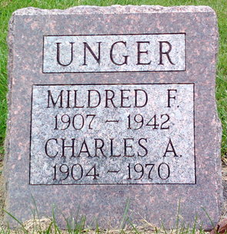
Photo by Thomas Liby

Milderd Florence Ander
in the Indiana, U.S., Death Certificates, 1899-2017
Name Mildred Florence Unger
[Mildred Florence Somers]
Gender Female
Race White
Marital Status Married
Age 34
Birth Date 17 Aug 1907
Birth Place Cincinnati, Ohio
Death Date 12 Jun 1942
Death Place Thorntown, Boone, Indiana, USA
Death Registration Date 1942
Father John Somers
Mother Anna Smith
Spouse Charles H Unger; age 37
Informant Charles Unger; Thorntown, Indiana
Burial June 14, 1942; Bluffton, Indiana

