Charles Andrew Unger
October 4, 1904 – October 28, 1970

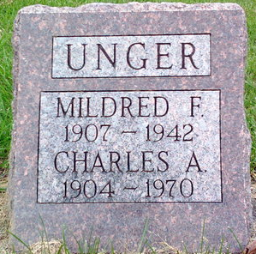
Photo by Thomas Liby

Charles Andrew Unger, 66, 1924 East 29th St., died early Wednesday morning at his residence after being in ill health for two years.
He was a native of Wells County, but had resided in Muncie for the past 22 years. Mr. Unger retired in 1966 as a meat cutter. He had been employed at Park 'N Shop Stores for 10 years.
Surviving are his wife, Wanda J.; one son, Charles David, Muncie; two daughters, Mrs. Joseph (Joan) Davis and Mrs. Harold (Kay) Lykins, both of Muncie; one brother, Robert Grove, Rochester; four sisters, Mrs. Jessie Studabaker, Muncie, Mrs. Herman Souder and Mrs. Shay Bates, both of Bluffton, and Mrs. Loren Gerwig, South Bend; eight grandchildren, and five great-grandchildren.
Services will be held at 10 a.m. Friday in Parson Mortuary with Rev. Roy Lee officiating. Burial will be in Elm Grove Cemetery, Bluffton. Callers will be received at the mortuary from 2-5 and 7-9 p.m. Thursday and prior to services Friday.

Unknown source
**

Indiana, U.S., Death Certificates, 1899-2017
Name Charles Andrew Unger
Gender Male
Race White
Marital Status Married
Age 66
Birth Date 4 Oct 1904
Birth Place Indiana
Death Date 28 Oct 1970
Death Place White City, Delaware, Indiana, USA
Father Clem Unger
Mother Ada Bennett
Spouse Wanda J
Informant Mrs. Wanda Unger; wife; Muncie, Indiana
Burial October 30, 1970; Elm Grove Cemetery; Bluffton, Indiana

