Sarah Josephine (Simeral) Ulmer
October 8, 1872 – January 13, 1944

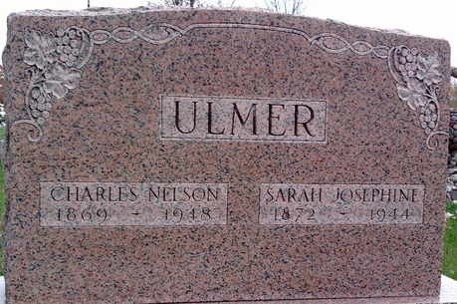
Photo by Thomas Liby

Mrs Charles Ulmer
in the Indiana, U.S., Death Certificates, 1899-2017
Name Mrs Charles Ulmer
[Mrs Charles Simeral]
Gender Female
Race White
Marital Status Married
Age 71
Birth Date 8 Oct 1872
Birth Place Belmont County, Ohio
Death Date 13 Jan 1944
Death Place Bluffton, Wells, Indiana, USA
Death Registration Date 1944
Father Samuel Simeral
Mother Sarah
Spouse Charles Ulmer
Informant Mrs. William Wile, Jr.; Bluffton, Indiana
Burial January 15, 1944; Elm Grove Cemetery; Bluffton, Indiana

